Term Project

NEURAL NETWORK - TRAVEL TIME FORECAST

Lim, Alyssa

Lim, Theo Paolo

Valdez, Esteen

______________________________________________

1. **INTRODUCTION**

Neural network is a branch of machine intelligence. In this paper, neural network will be used to predict the travel time of a person going to Vito Cruz. The inputs are the capacity of people and distance of travel going to Vito Cruz. The capacity of people will be in percentage format (e.g. 50% load capacity). While the distance is on kilometers (e.g. Carriedo going to Vito Cruz will be 4.99 km). The output is the travel time; these include the waiting time inside the platform and the travel time of the train. Knowing the travel time going to Vito Cruz may help the students adjust their time so that they will not be late. This algorithm may also help the train management to find solutions to reduce the travel time of its passengers. The training data will consist of 200 samples with inputs regarding the capacity of people and travel distance.

Neural Network are used to estimate or approximate large number of inputs and usually unknown. Neural network learns from its training data; it has been used in different tasks including computer vision and face/speech recognition. Many are using neural networks already, because its ability to derive meaning from complicated or imprecise data (e.g. extract patterns and detect trends).

1. **PROCEDURE**

Fig.1 is the 20 sample training data for the travel time forecast. The first column is the total distance going to Vito Cruz. The second column is the percentage of passenger load. And the last column is the output travel time of each passenger.

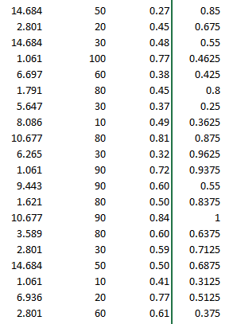

Fig.1. 20 Sample Training Data

We made use of MATLAB’s Neural Network Fitting Tool (nftool). “nftool” leads in solving a data fitting algorithm using Levenberg – Marquardt (Fig.2).

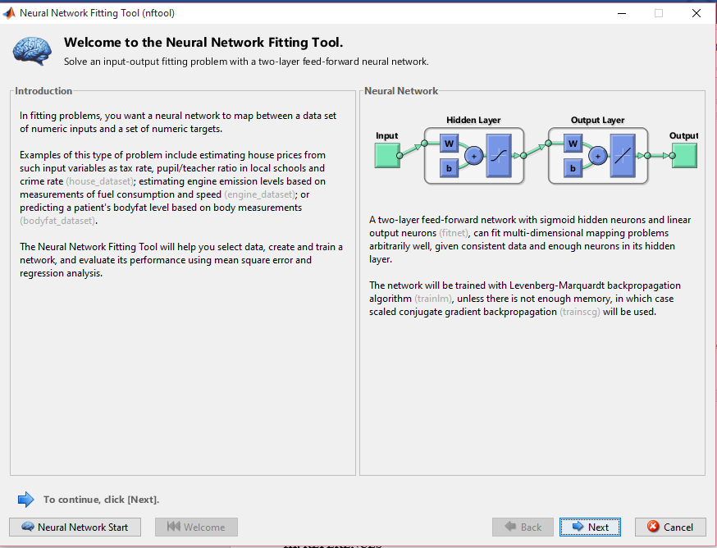

Fig.2. Neural Network Fitting Tool

Then the program itself is straight forward. The input and output must be assigned to the training data.

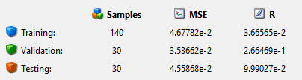

Fig.3. Train, Validation, and Test

The group divided the samples into 140 training, 30 validations, and 30 testing (Fig.3) The group allocated the samples into training so that it will prioritize the training data. We retrained the data in order to obtain a MSE into minimum and R

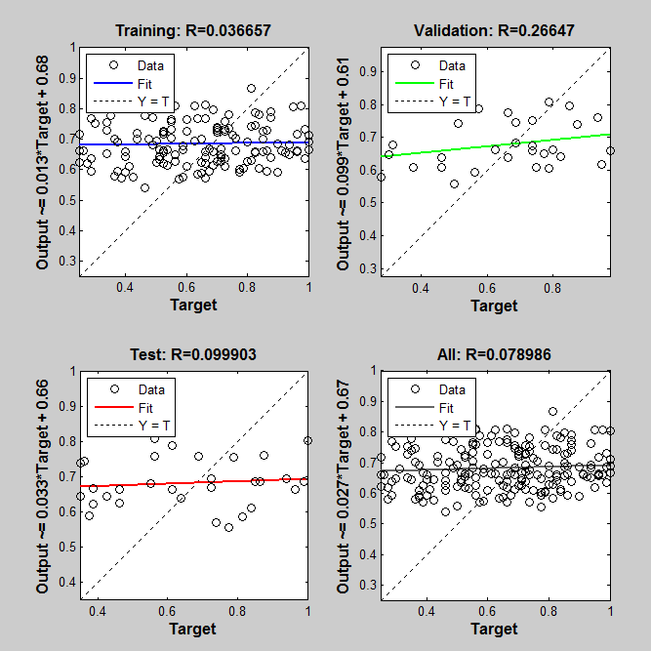

Fig.4. Cost Function Plot

Fig.4. shows the four regression plots regarding the training, validation, and testing. While the last plot shows all the 3 parameters. The figure showed an exact fit to the training data.

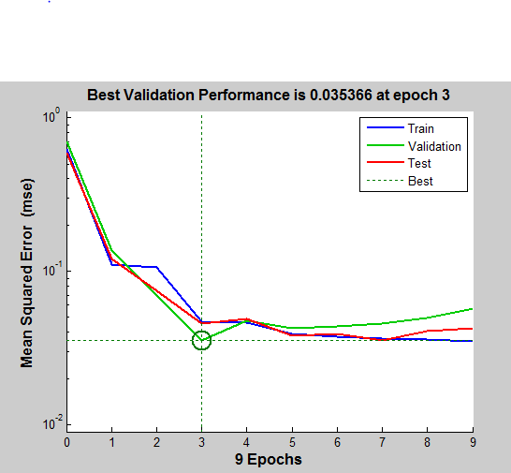

Fig.5. Mean Squared Error Plot

Fig.5. shoes the mean squared error plot (MSE). Mean squared is arguably the most important criterion used to evaluate the performance of a predictor. The group also included the Error Historgram (Fig.6)

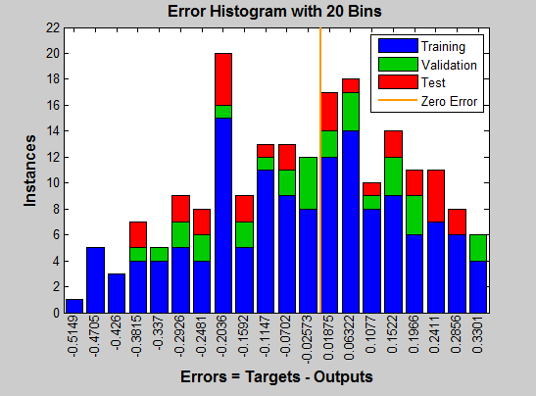

Fig.5. Mean Squared Error Histogram

1. **CONCLUSION**

In this project, we used a tool in MATLAB called Neural Network Fitting Tool to fit the training data that was inputted. The training data is composed of 3 inputs which are loading capacity of the train, time, and distance from Vito Cruz Station to the different stations. The output is the travel time. The training data is composed of 200 data. After fitting the data with the data fitting algorithm we were able to get the plots needed.

1. **REFERENCES**

[1] Farley, B.G.; W.A. Clark (1954). "Simulation of Self-Organizing Systems by Digital Computer". IRE Transactions on Information Theory 4 (4): 76–84. doi:10.1109/TIT.1954.1057468.

[2] A. Graves, M. Liwicki, S. Fernandez, R. Bertolami, H. Bunke, J. Schmidhuber. A Novel Connectionist System for Improved Unconstrained Handwriting Recognition. IEEE Transactions on Pattern Analysis and Machine Intelligence, vol. 31, no. 5, 2009.